1 Write Java programs to create an array an initialize and print the elements

1. Calculate the average of numbers using Array.

Convert char Array to String

Add two Matrix using Multi-dimensional Arrays

Find out the min numbers in an array.

Create a student class using student properties and create and execute a method without a constructor.

Create a Product class with constructor (observe the difference with or without constructor)

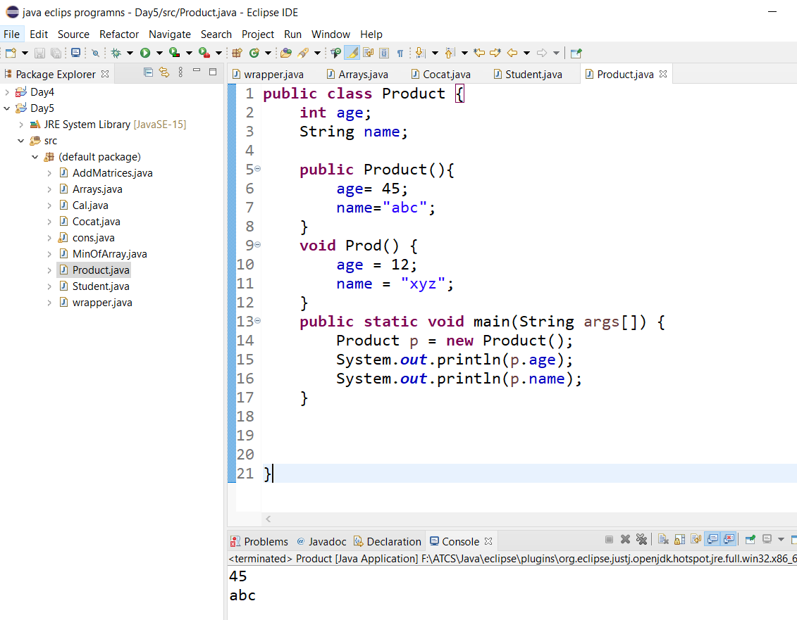

Create a Student class without parameters and with parameters by using constructor.

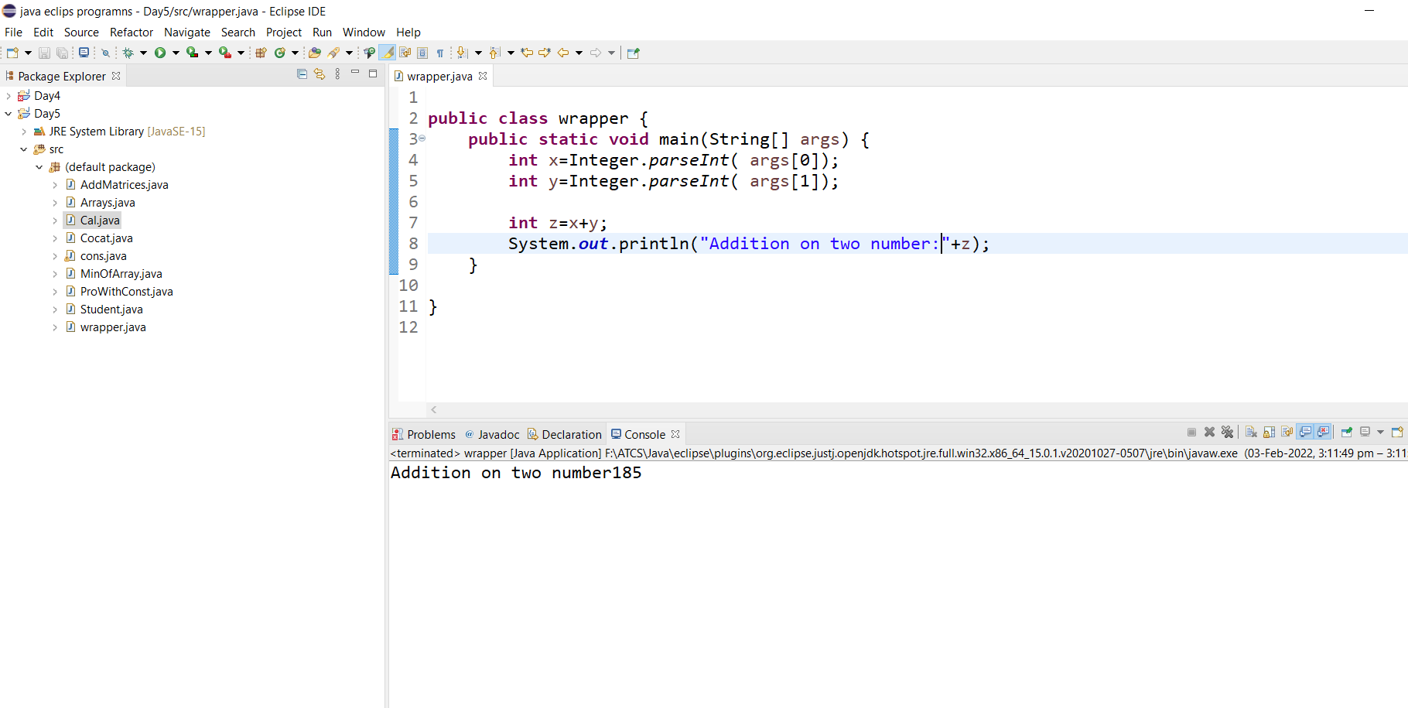

Create a Calculator class and create static methods with or without return type.

Create a class Add add two numbers by using Wrapper class